
上海德百实电器电子有限公司
Shanghai TPS power Electronic Co., Ltd

CE Declaration of Conformity
It is hereby declared that following designated product:
Product Type: AC/DC Bidirectional Power Module
ModelNo:TPS-BM142250SIR,TPS-BM142400SI,TPS-BM142650SI,TPS-BM142650SIR,TPS-BM143400SI,TPS-BM143400SIR
Complies with the following:

Standards
EN55032:2015 | IEC61000-3-2:2018
IEC61000-3-3:2013+AMD1:2017 | IEC61000-4-2:2008
IEC61000-4-3:2006 | IEC61000-4-4:2012
IEC61000-4-5:2014/AMD1:2017 | IEC61000-4-6:2013
IEC61000-4-11:2004/AMD1:2017 | IEC61000-4-8:2009
EN62368-1:2014+A11:2017
IEC62321-3-1:2013 | IEC62321-5:2013
IEC62321-4:2013+A1:2017 | IEC62321-6:2015
IEC62321-7-1:2015 | IEC62321-7-2:2017
IEC62321-8:2015

Directives:
2014/35/EU(LowVoltage Directive)
2014/30/EU(EMC Directive)

RoHS Directive:
2011/65/EU 2011/65/EU: The use of certain hazardous
(EU)2015/863 substances in electrical and electronic equipment
REACH Directive: (Recasts and supersedes 2002/95/EC)
EG-No. 1907/2006

Name: Shanghai TPS Power Electronic Co., Ltd.
Address: 2/F Blk 19 No.201 Minyi Rd. Songjiang District Shanghai China
Authorized person signing for the company:
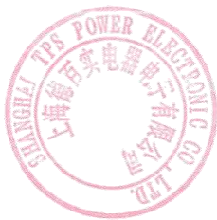
Zhiyi Li General Manager
Name in block letters & position in the Company.
Place & date Legally valid signature & chop
Shanghai Oct. 23, 2019

